**Jenkins assignment 02**

**Go to manage jenkins in securiy sectio there is one option user click on that and the create multi users.**

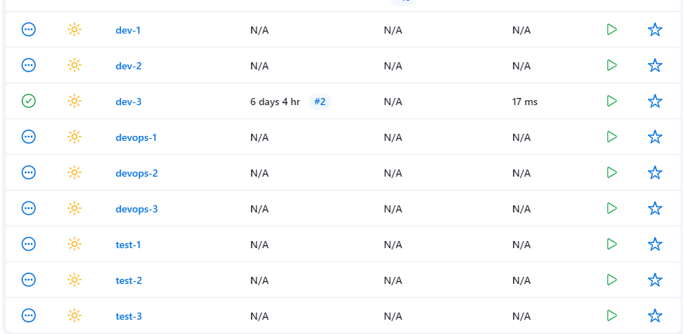

# Go to manage jenkins click on plugin option and the click on available plugin and the install Role-based Authorization Strategy plugin and the go to security option enable Role-based Authorization Strategy plugin and then click on manage and assign role and the configure it.

# 

# 

# 

# Check every user

# C:\Users\abc\Desktop\combine.png

**Now follow the step by step blogs to create the SSO enable**

**Link for blog:>** [**https://opstree.com/blog/2023/05/09/how-to-setup-sso-in-jenkins/**](https://opstree.com/blog/2023/05/09/how-to-setup-sso-in-jenkins/)

After completing all the blog steps the output becomes:-

Sso with jenkins

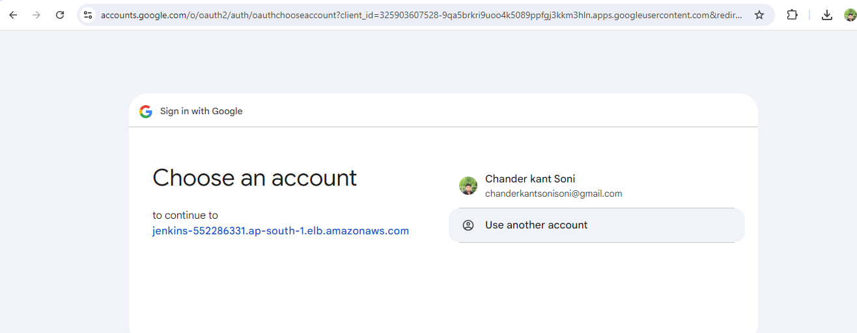

Login sso with google ID

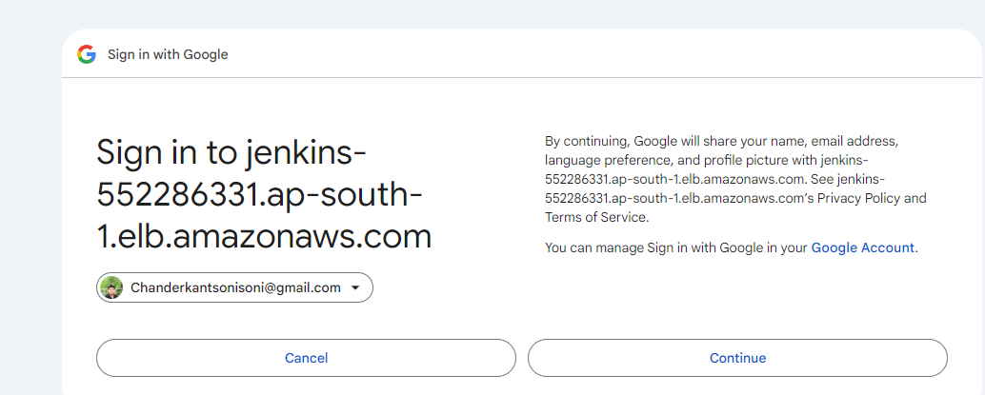

Successfull login into jenkins via google SSO

